St. Thomas the Apostle Advent Giving Tree 2023 in Five Easy Steps
- Follow the link to Signup Genius at https://www.signupgenius.com/go/10C0845ACA62BABFFCF8-45492527-advent
Or scan the QR code on the right on your cellphone or tablet.
- Check off the item(s) you are able to donate then hit “Submit and SignUp”
Note you may see advertisements on the signup page. They are not sponsored by Saint Thomas or related to the Advent Giving Tree. Click on No Thanks.
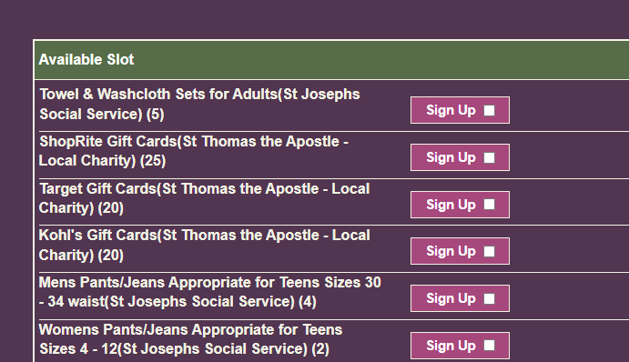
- Fill out the following form (name and email required just in case we need to contact you) and click “Sign Up Now”
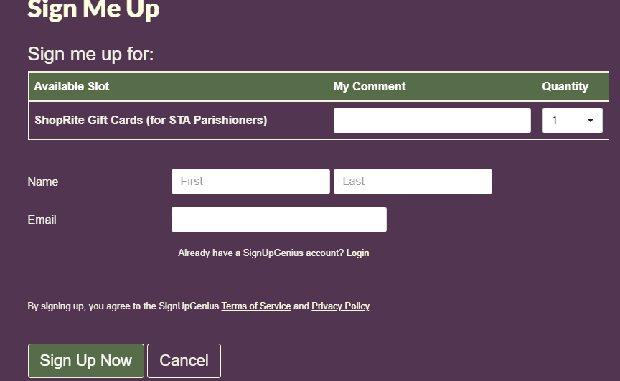
- Look for a confirmation email. This will allow you to adjust your donation if you need to.
- Look in the bulletin and/or listen to the announcements for drop off information.
  - Please label items with the name of the organization.
  - Please do not wrap gifts – place items in gift bags or plastic bags.
  - Please put $$ value on the gift cards
Thank you and God Bless.

